**Introduction**- BARE International is a customer experience research company that offers a variety of services, including business intelligence (BI) analysis, mystery shopping, and data analytics.

**Introduction & Objectives-** In the dataset we have raw dump and after cleaning the same we have the object to figure out Evaluation scores, Performance grade, Zone wise grade etc.

By doing all the activity we can analyse all the expected aspect of the data.

**Data Overview-** Raw data for the analysis is of 62 rows and 83 columns. The data is all about one organisation where several Q&A response were recorded.

**Performance Grading-** To perform action on data we made it clean as per requirements, after the same we gave the grading as required.

**Formula used for grading -** =IFS(C2>89,"High Performer",C2>69,"AVG Performer",C2>49,"Low Performer",C2<50,"Bottom Performer")

**Sample view of grading**-

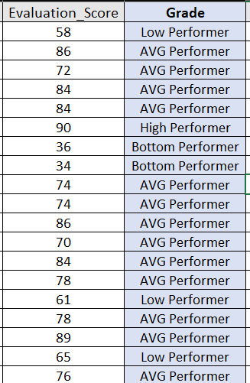

**Pivot Table Analysis-** Second step after grading was to show evaluation scores average using pivot table.

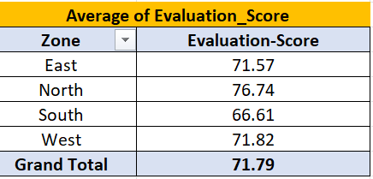

Above view in pivot table can be found by dragging the Zone is Rows and Evaluation scores in Values. After performing the same we need to change the value field settings and select Average instead of SUM.

**High Performer Analysis –** After preparing the above pivot we prepared analysis table of High Performance.

To achieve the data we again applied pivot in existing sheet and chose Zones in Row and Grade in values where the filter was applied and only high performer grading was selected.

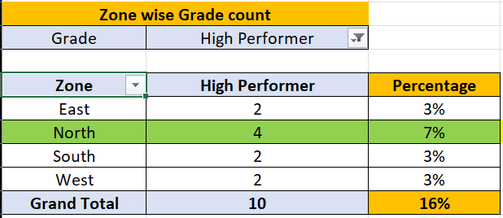

To find out the percentage, we will divide the number of High Performers by the total number of evaluations. Data will be same as shown above.

**Visualization**

**Bar chart: Average Evaluation Scores by Zone –**

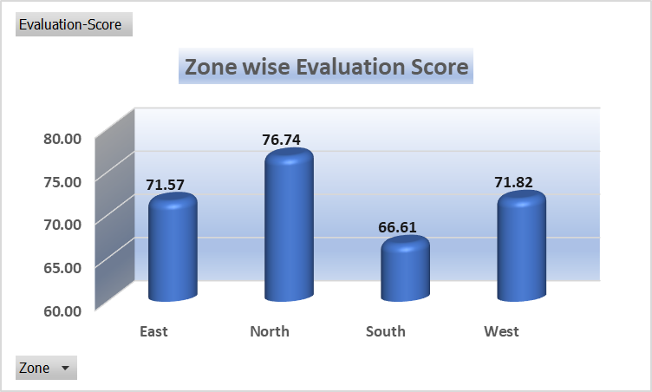

**Pie chart: Percentage of High Performers by Region-**

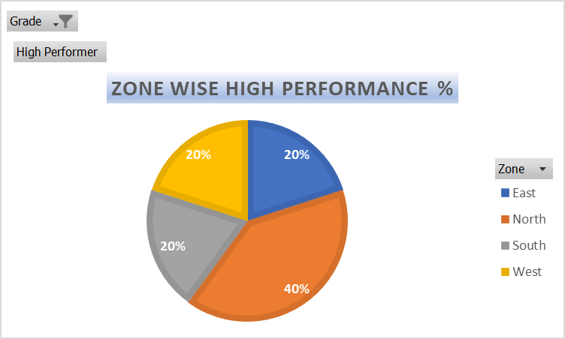

**Line graph: Performance Trends Over Time-**

**Heatmap: Breakdown by Evaluation Criteria-**

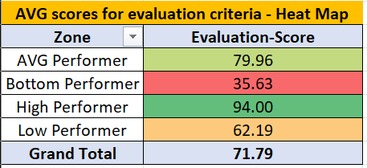

**Stacked bar chart: High vs. Low Performers Comparison-**

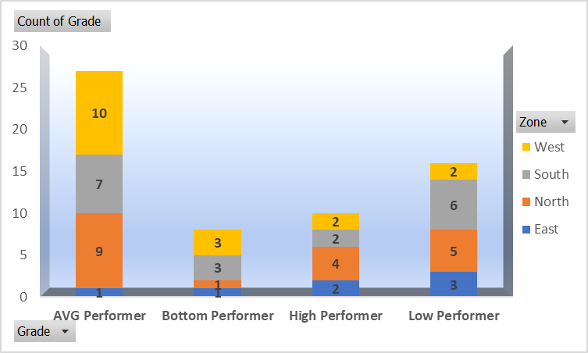

**Key Insights –**

As per the analysis overall 16% contribution is found for high performers and the analysis is mentioned below. As per the analysis Zone North is at 7% which is highest among all and same prove that the North zone contains maximum number of top performers as per grading system.

High performance is observed due to scoring good in Objection Handling, Trial Room, Care etc.

Low Performance is due to drastic impact on Care and closure and trial experience.

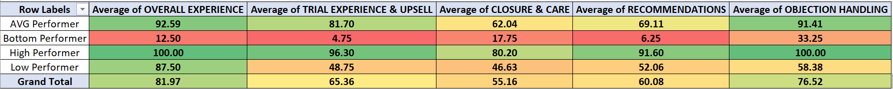

**Recommendations-** As per the overall analysis we are aware about the root cause and by creating the action plan / glide path the same can be fixed.

Based on the ranking and scoring step targets should be given and weekly performance should be reviewed.

Realtime quality check should be implemented and count of shared feedback should be increased.

For outliers, the area of improvement should be taken care and the TNA should be introduced if needed.

**Conclusion-** Several analysis and quality check were performed by cleaning the data and this is clearly visible that the opportunity areas are there. Ny working on this, down areas and the BQ can be fixed and overall revenue can be increased by giving the good number of high performers from each region.

Will Introduce the action plan along with step target and glide path to spike up in trend of high performer where the zones are struggling to achieve the good number in performance.